10.10 Templates

10.10.1 Saving templates

gvSIG allows the configuration of a map to be saved as a template. This can then be used at a later date with different data sources.

The element distribution and properties from a map can be saved.

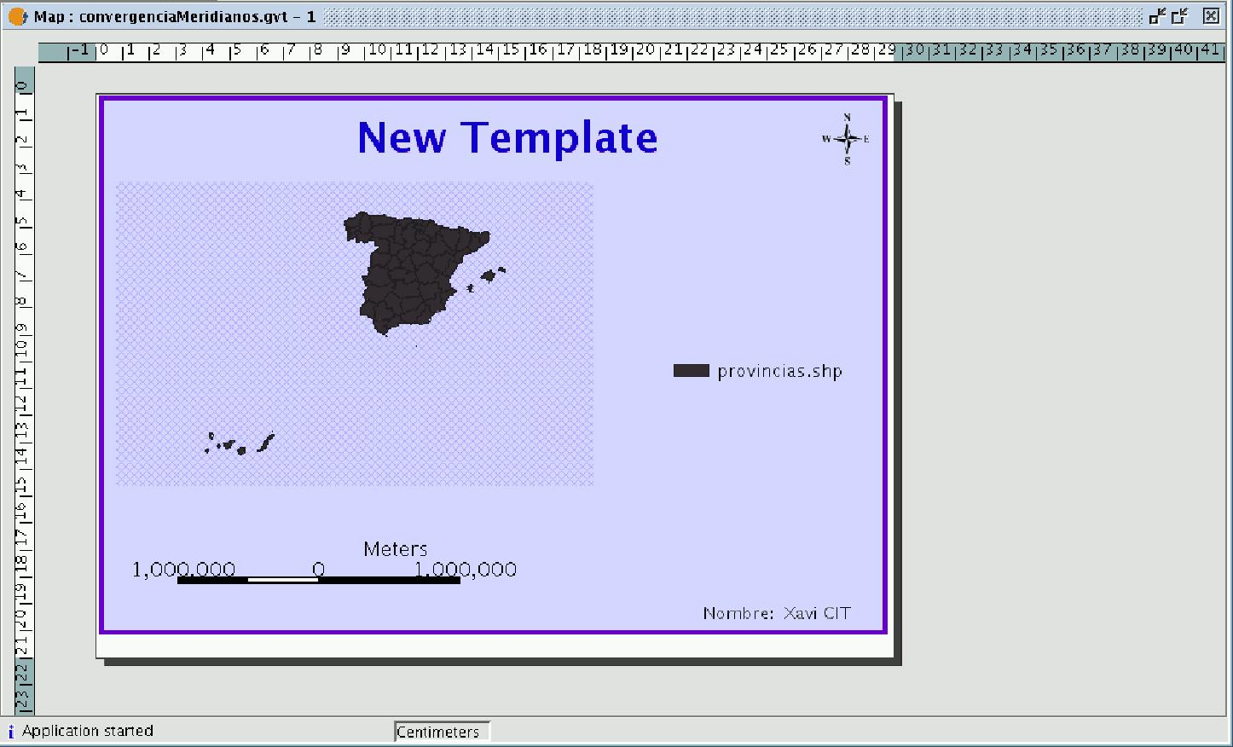

If you click on the “File” menu then on “Save as template”

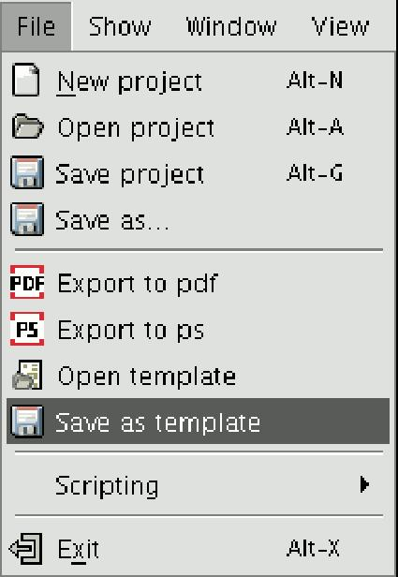

a dialogue box appears so you can save your .gvt file which can be recovered at a later date and will allow you to reconstruct the map configuration.

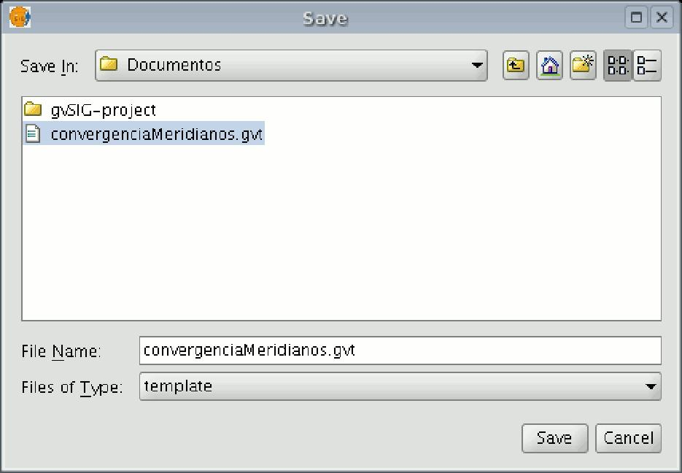

10.10.2 Open template

If you wish to retrieve a saved template to use it in a new project, go to the "File" menu and then to "Open template".

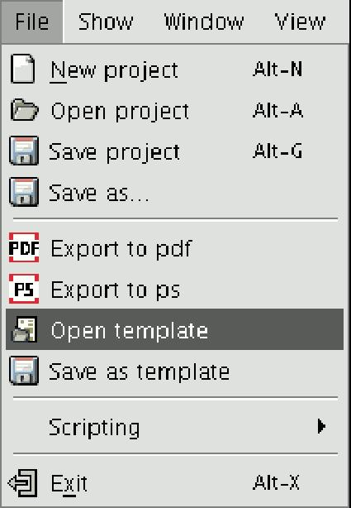

10.11 Printing



This option opens the printing dialogue box from which you can select the printing options (selecting printer, quality, etc.).

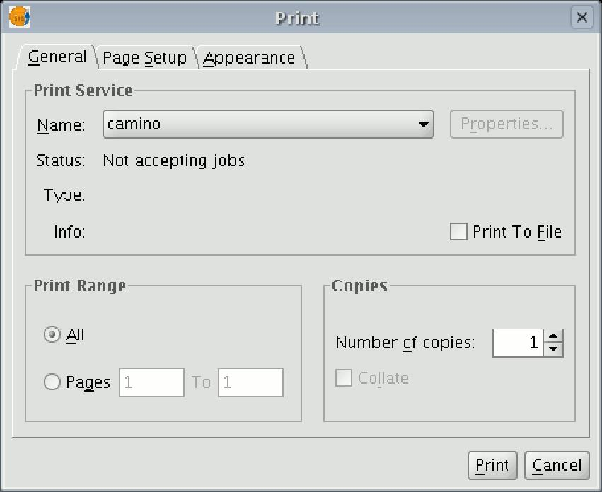

N.B.: The specifications which are not enabled depend on the type of printer installed.

10.12 Tools for exporting to postScript and pdf

You can use these tools to export a layout to a postScript and/or pdf file by going to the "File" menu and then selecting "Export to ps" or "Export to pdf" respectively

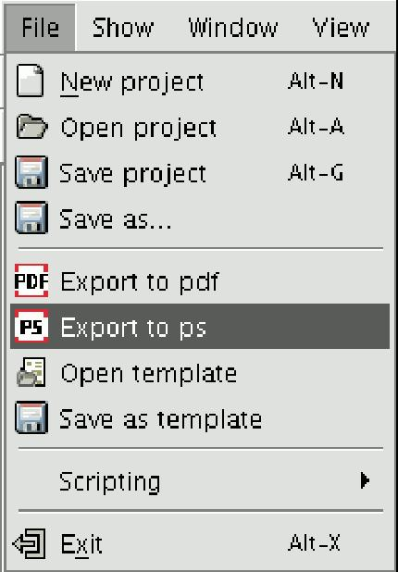

or by clicking on the following buttons in the tool bar:

This opens a dialogue box in which you are asked to specify a file to save the resulting postscript file (with the .ps extension) or pdf file (with the .pdf extension). When you have selected where you wish to save the document, click on “Save”.

