9.9 Difference

9.9.1 Introduction

The “Difference” geoprocess works with two layers, the “input layer” and the “overlay layer”. It is known as “Spatial NOT” and allows you to obtain the areas in a layer which are not present in the other layer.

The geometries in both the “input layer” and the “overlay layer" must be polygons. The alphanumerical schema of the “input layer” will remain intact in the "result layer", as in the end it gives more information about it.

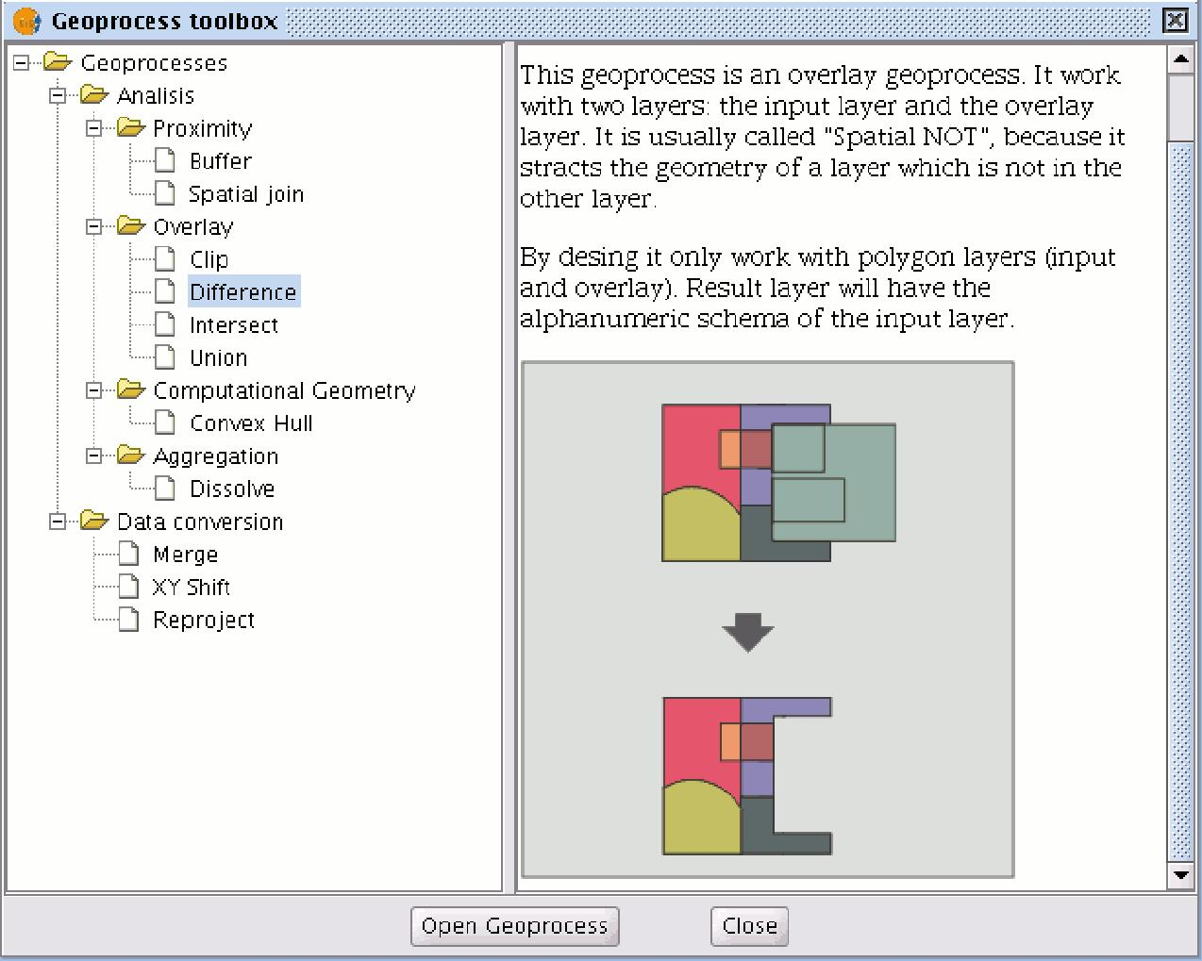

This geoprocess is very useful in numerous situations. For example, it can be used to complement the "Clip" geoprocess. If “Clip” allows you to exclude everything that does not belong to a geographical area under study, "Difference" allows you to do exactly the opposite; exclude a specific area from our working layer.

A useful example:

- Transferring territorial jurisdiction between different governing bodies. Thus, if the national government transfers certain jurisdiction to a regional authority, it can decide to exclude the geographical area of the transfer in question from its data bases.

9.9.2 Running the “Difference” geoprocess

Click on the “Open Geoprocess” button to access the dialogue window which allows you to run the "Difference" geoprocess.

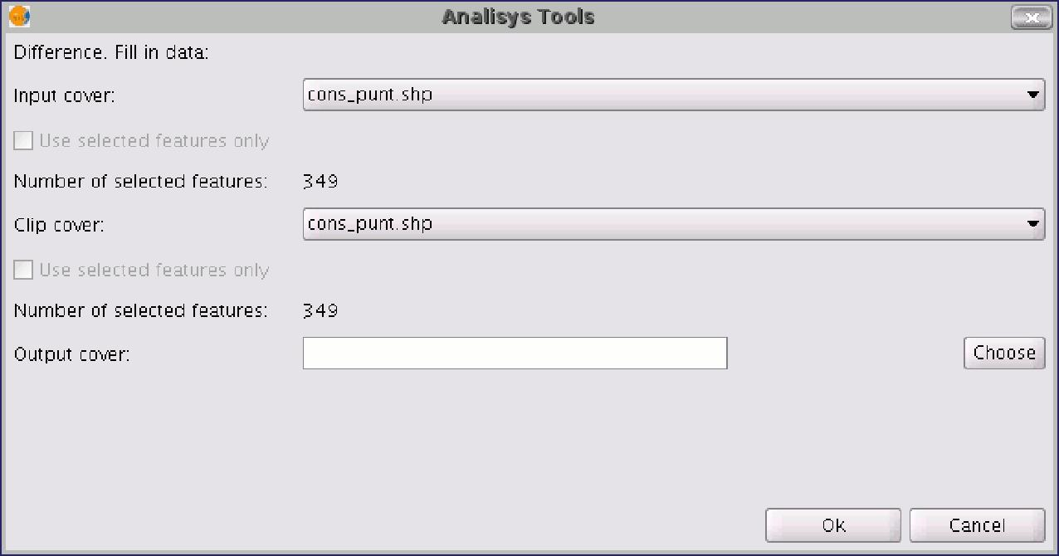

You can enable the “selected features” check boxes at this point of the geoprocess for the input layer and the overlay layer. If you click on the “Ok” button, the geoprocess will be run.
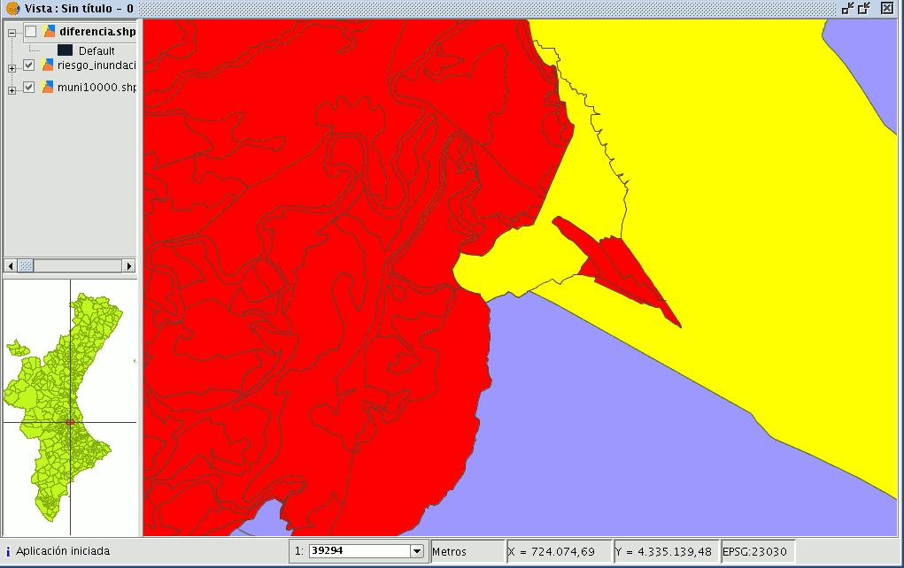

In the following image, the “Difference” geometry appears in black between a flood zone and one of the selected cities or towns.

In this case, the new layer resulting from the calculation of the difference will take the schema (alphanumerical attributes) of the geoprocess input layer.

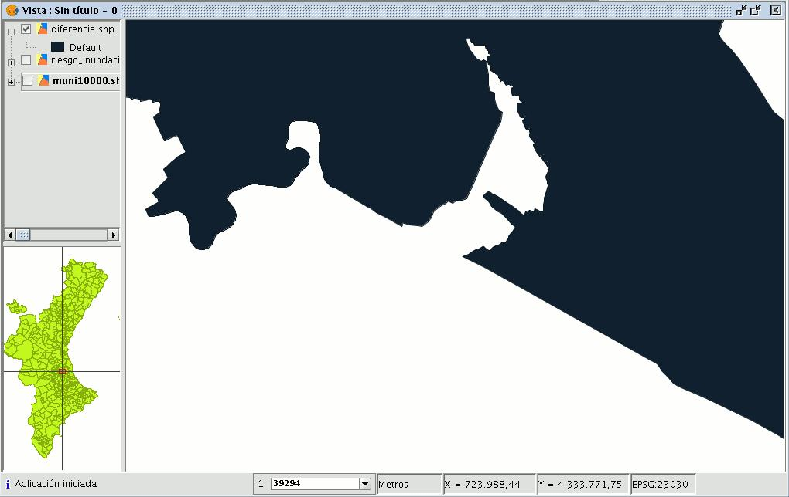

9.10 Union

9.10.1 Introduction

This geoprocess is similar to the “Intersection” and "Difference" geoprocesses in that it operates on two polygon layers to obtain their intersections (this is why these three geoprocesses are known as “overlay geoprocesses”).

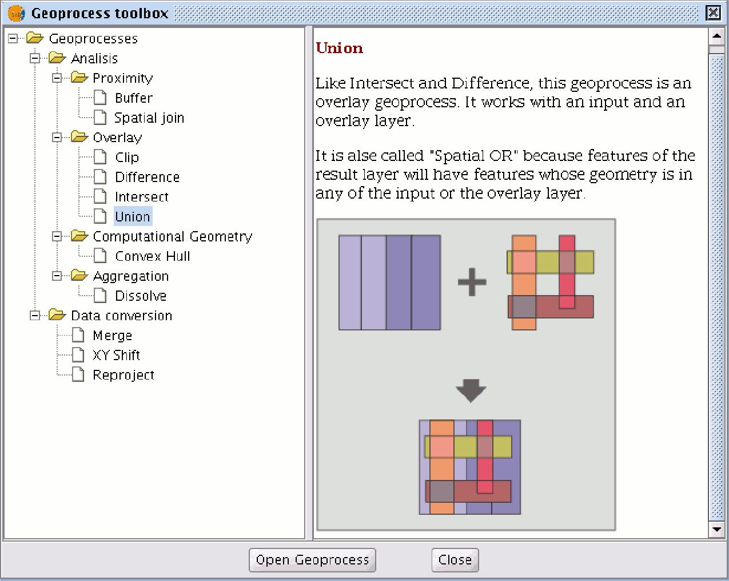

The "Union" geoprocess is known as "Spatial OR", because the result layer is made up of the geometries which appear in the two layers (intersections between the polygons), plus the geometries which only appear in one of the two associated layers. This means that the geoprocess carries out three analyses: the first time it calculates the intersection of both layers, the second time it calculates differences between the the first layer and the second, and the third time it calculates the differences between the second layer and the first.

This geoprocess may be of interest if you wish to generate new layers which show the occurrence of two phenomena so that the occurrence of one of the two or of both is highlighted.

9.10.2 Running the "Union" geoprocess

If you select the “Union” option, the following dialogue appears:

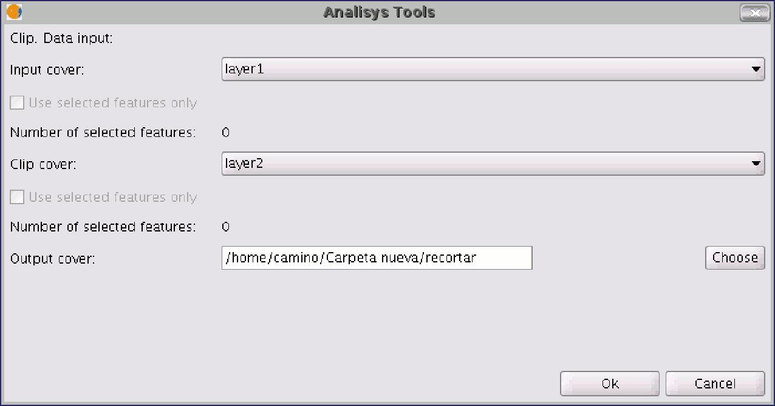

When you have selected the input layer, the clip layer and an output layer, click on "Ok".

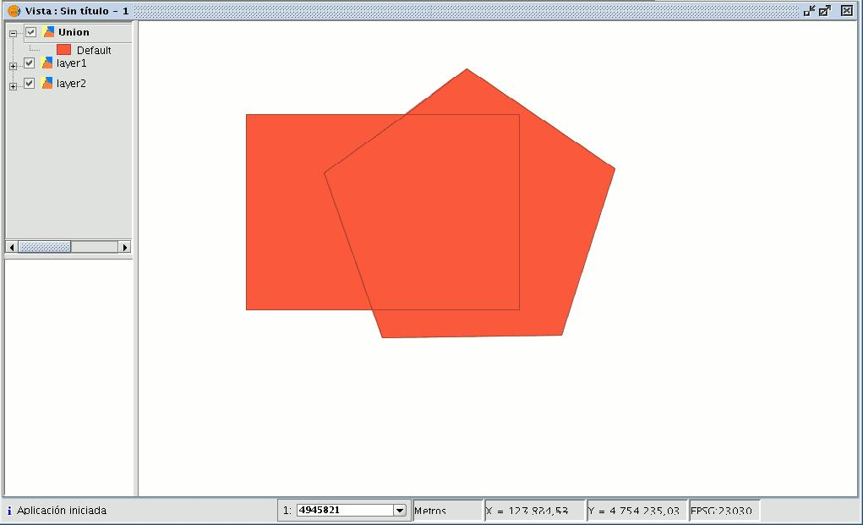

The result layer will have all the intersections and differences between the two layers. If you click on the “Information” button and then on the different polygons in the result layer, you will see that the intersections have all the attributes, whilst the differences only have the attributes of the layer that created them.

