9.7 Convex hull

9.7.1 Introduction

This geoprocess calculates the “Convex hull”, or the smallest convex polygon which surrounds all the vector elements in an “input layer”.

It only works with an “input layer” whose geometry type can be any type (point, line or polygon).

There are different types of applications for this geoprocess:
- Determining the coverage area for a specific geographical phenomenon.

- Calculating the diameter of the area covered by a series of geometries, etc.

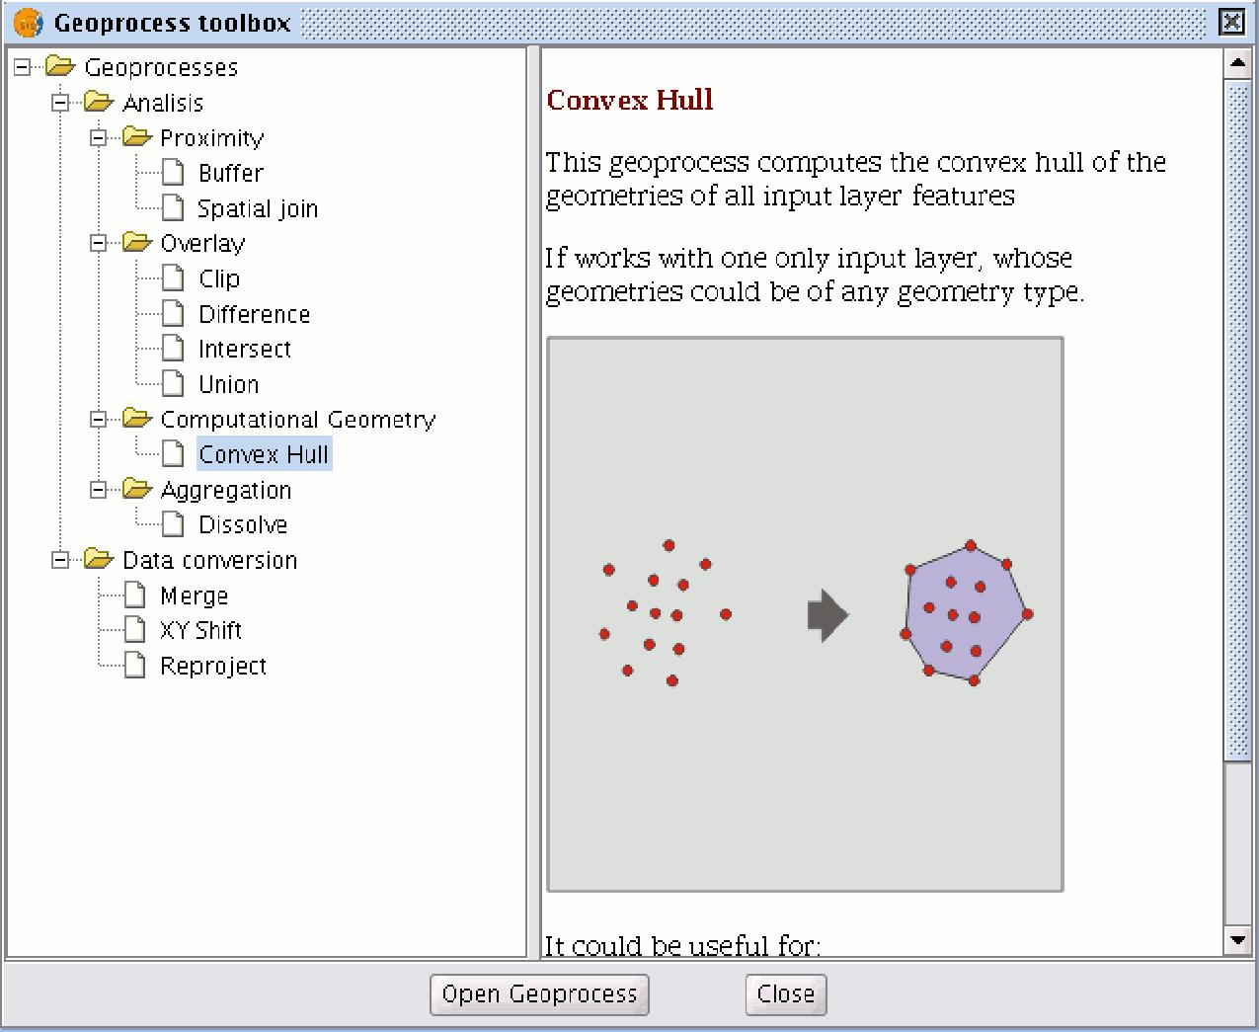

9.7.2 Creating a convex hull

If you select the “Convex hull” geoprocess, the following dialogue appears:

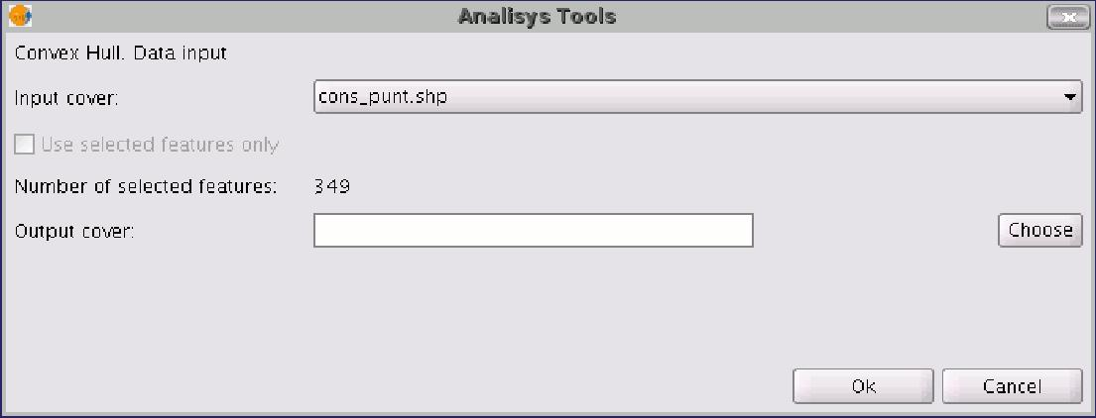

After selecting the layer whose “Convex Hull” you wish to calculate and specifying an shp result file, you can run the geoprocess and generate a new result layer.

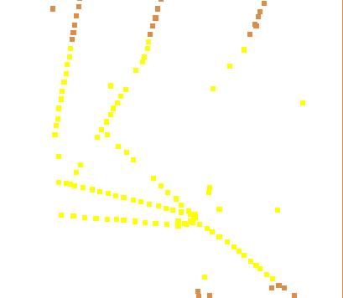

The following image shows the convex hull created which surrounds all the points in the input layer.

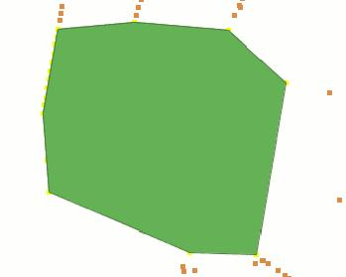

9.8 Intersection

9.8.1 Introduction

This geoprocess operates on two layers, the “input layer” and the “overlay layer”, whose geometries must be polygons.

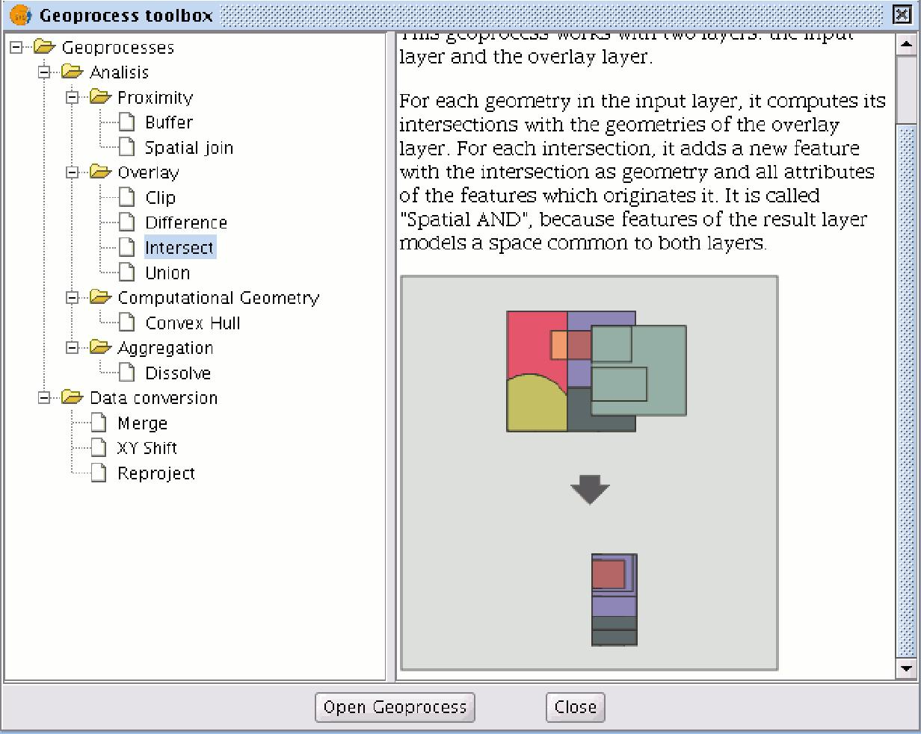

It calculates the intersection with the different geometries in the “overlay layer” for each geometry in the “input layer”, thus creating a new element for each intersection. This element will take all the alphanumerical attributes in the geometries that created it (input and overlay). This is why (it models space areas which comply with the condition of belonging to the two polygons that created it) this geoprocess is known as “Spatial AND" operator.

An example of how this geoprocess can be applied:

- Given a land use layer (e.g. Corine2000), and a national geological map layer, you can obtain a polygon layer with homogeneous information on land use and geological material.

9.8.2 Running the “Intersection” geoprocess

After selecting the "Intersection" geoprocess, the following dialogue appears:

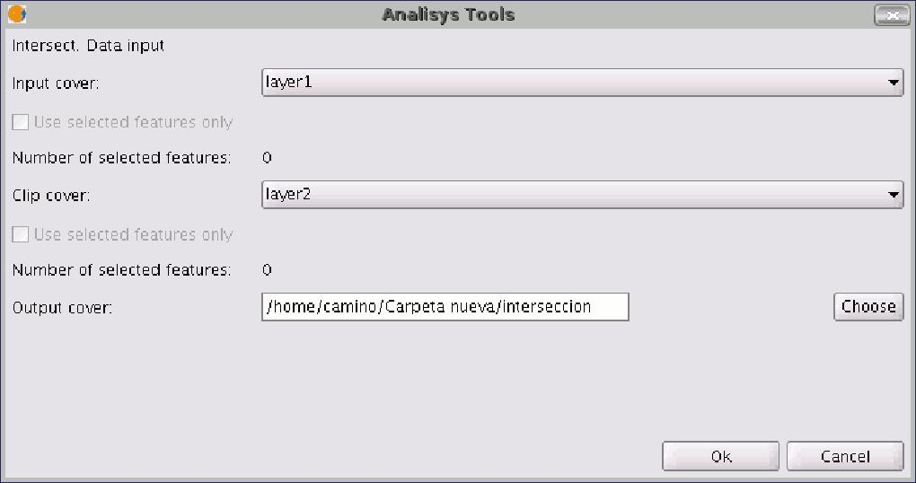

Select the input layer and the overlay layer. You must also specify a file in which to save the results. Finally, click on "Ok" and the geoprocess will be run.

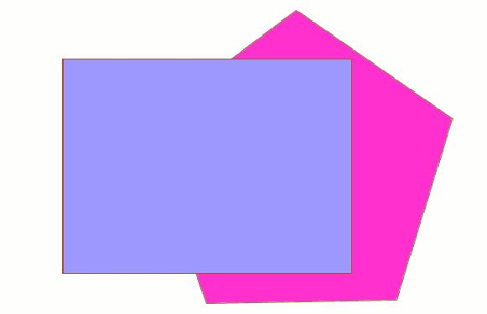

In this case, we will use a very simple example to better understand the function of the geoprocess. The previous figure shows two overlaying polygons. The result of launching the “Intersection” geoprocess with these layers as parameters is as follows:

