9.11 Spatial Join

9.11.1 Introduction

This geoprocess allows you to transfer the attributes of one layer to another based on a common element. In contrast to the join sql operator in the relational data bases, in this case, the common element is not that a field of the two tables takes the same value, but that the related elements in the two layers meet some spatial criteria.

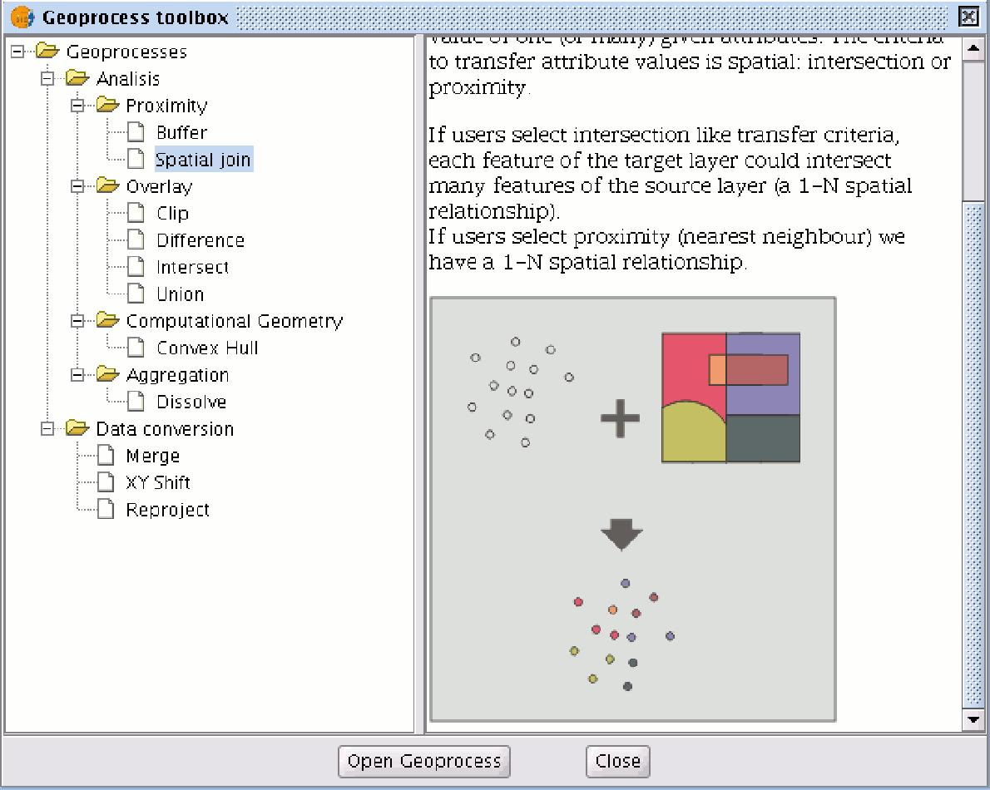

The “Spatial join” geoprocess allows you to follow two types of spatial criteria to establish the spatial link:

- Nearest neighbour (1->1 relationship). This assigns the attributes of the nearest element in the related layer to an element in the source layer. If the nearest element intersects (or in the case of polygons is “Contained in”) with the source element, the algorithm will take the first element analysed in the possible intersections.
- Contained in (1-> M relationship). This relates an element in the source layer with several elements in the destination layer (in particular, with those that intersect). In this case, the source layer will not inherit the related layer’s attributes, but the operation will be very similar to the "Dissolve" geoprocess. The user can choose one or several summary functions (average, minimum, maximum, summatory) to be applied on the numerical attributes of the related layer for the M elements related to an element in the source layer.

9.11.2 Running a “Spatial Join”

When you have selected the "Spatial join" option, the following window appears:

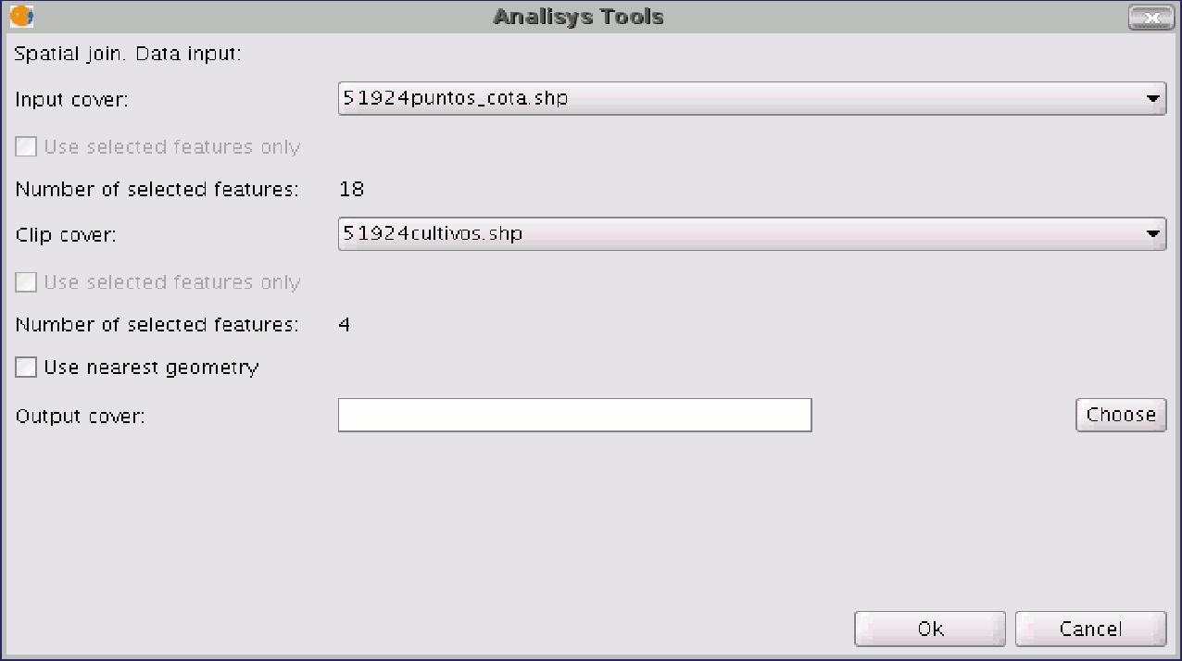

This window is practically the same as the windows in the overlay geoprocesses (Union, Difference, Intersection) with one difference. It allows you to choose whether you want to run a 1-1 relationship (using the nearest neighbour spatial criterion) or run a 1-N relationship (using the “Intersect” or “Contained in” spatial criterion). The choice can be made by enabling or disabling the "Use nearest geometry" check box.

If when you have selected the source layer and the layer to be related, the geoprocess is launched and you have not enabled the "Use nearest geometry" check box, a window appears in which you can select the summary functions you wish to apply for each numerical attribute of the layer to be related:

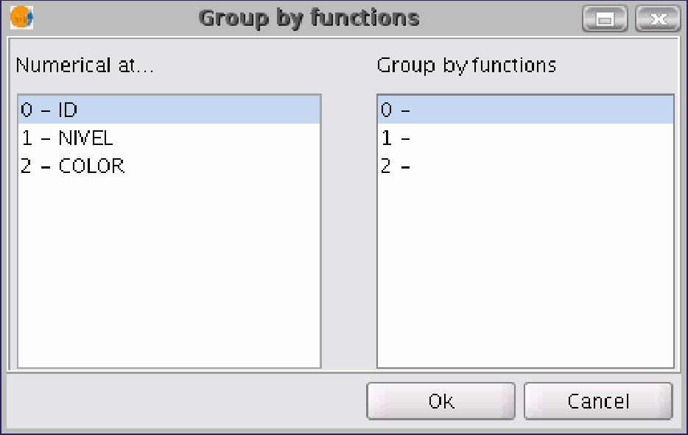

The summary functions are the same as in the “Dissolve” geoprocess:

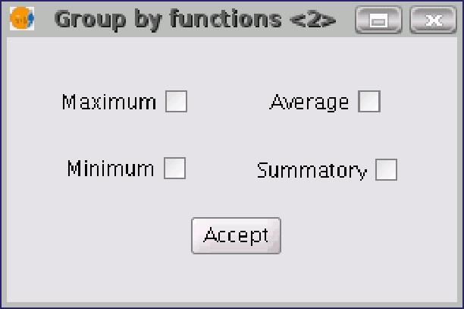

Thus, the attributes transferred to the source layer will be the result of the summary functions selected for each numerical field. If you run the geoprocess and the “Use nearest geometry” option is enabled, this window does not appear.

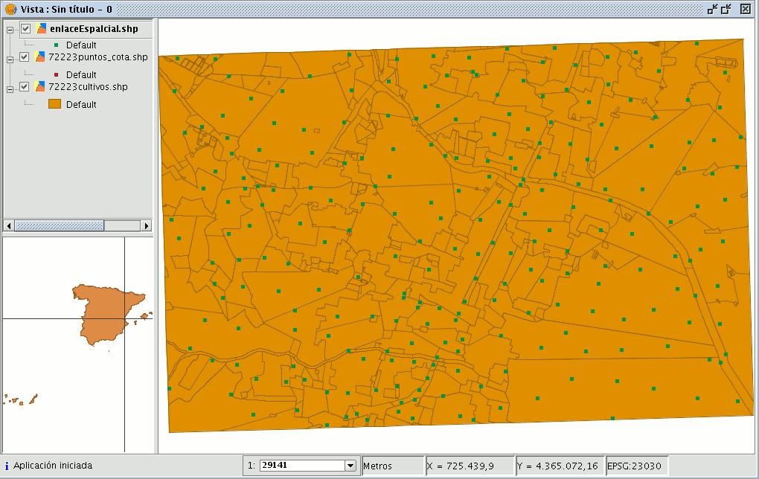

9.12 2D Translation

9.12.1 Introduction

This geoprocess allows a translation transformation to be applied to all the points, lines and polygons of the geometries in the input layer. The geoprocess can be applied to all types of vector layers (shp, dgn, dxf…). To do so, the movement on X and Y must be specified.

This geoprocess is extremely useful when combining cartographies which come from different sources, a process which is referred to as conflation.

Bear in mind that although translations can be carried out on all types of vector layers (shp, dgn, dxf, dwg…), the resulting output layer will always be a shape file. In other words, the input layer can be a shp, dxf or dgn file, but when translation is applied to these layers, the result will be one or various different output layers which are always shape files.

When a translation is carried out in which the input layer is a vector layer which is not a shape file, the result of the translation will be three layers in SHP format (one line layer, one point layer and one polygon layer).

If, for example, the input layer to which the translation is applied contains only points and lines, the polygon .shp file will be created but it will be empty.

NB. At the end of this section there is a table giving details of the relationship between the type of input file and the resulting output layer.

9.12.2 Translating a vector layer

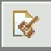
Firstly, load a vector layer in gvSIG and then click on the geoprocessing wizard in the tool bar.

Select the option “2D Translation” from the “Data Conversion” folder.
Click on the “Open Geoprocess” button and the geoprocess data input window opens.

For the input layer, select the vector layer (dgn, dxf, dwg, shp…) you wish to translate and introduce the values corresponding to X and Y.

Select an output layer and click on “Ok”.

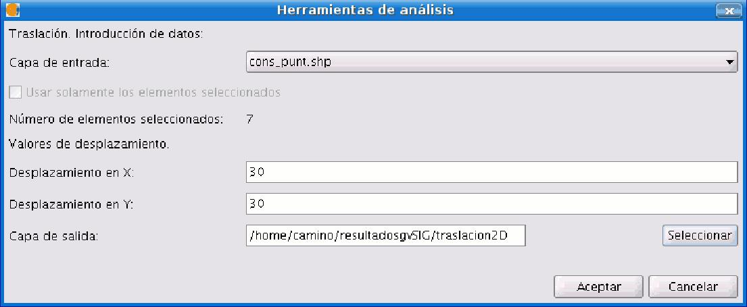

The following image shows the result of applying the translation process.

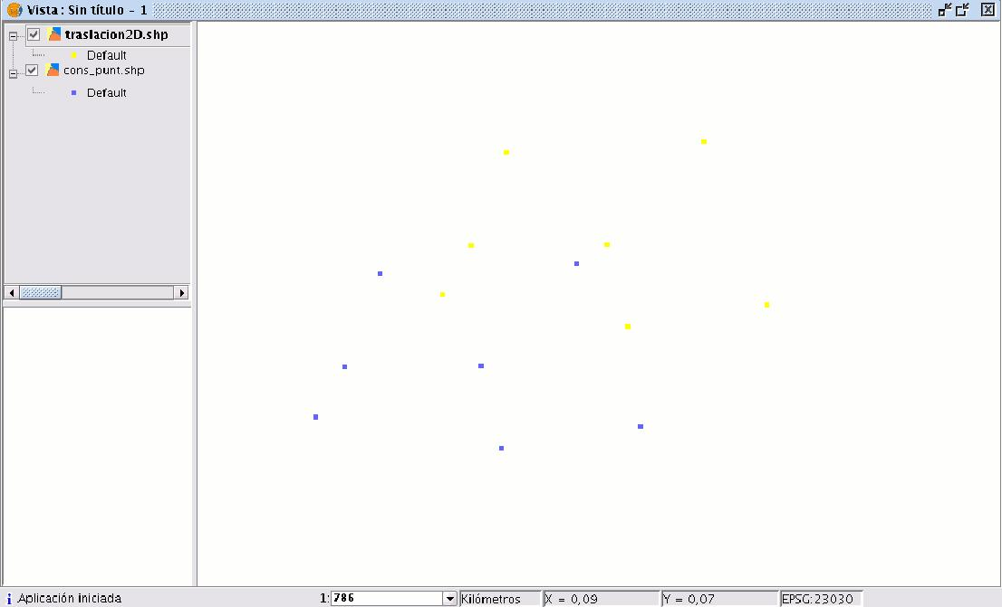

Relationship between the type of layer before and after translation.

Input layer | Output layer/s
Point Shp file | Point Shp file
Multipoint Shp file | Multipoint Shp file
Line Shp file | Line Shp file
Polygon Shp file | Polygon Shp file
Dxf (points, lines, polygons) | Point Shp file, Line Shp file, Polygon Shp file
Dgn (points, lines, polygons) | Point Shp file, Line Shp file, Polygon Shp file
Dwg (points, lines, polygons) | Point Shp file, Line Shp file, Polygon Shp file

9.13 Reprojection

9.13.1 Introduction

This geoprocess allows you to change the geodesic projection of the vector elements in the input layer. In order to do so, the user must specify the new projection to be applied.

This process is extremely useful when standardising cartographies in the same project if these are in different projections.

9.13.2 Reprojection of a layer

Click on the geoprocessing wizard in the tool bar and select the “Reproject” option from the “Data conversion” folder.

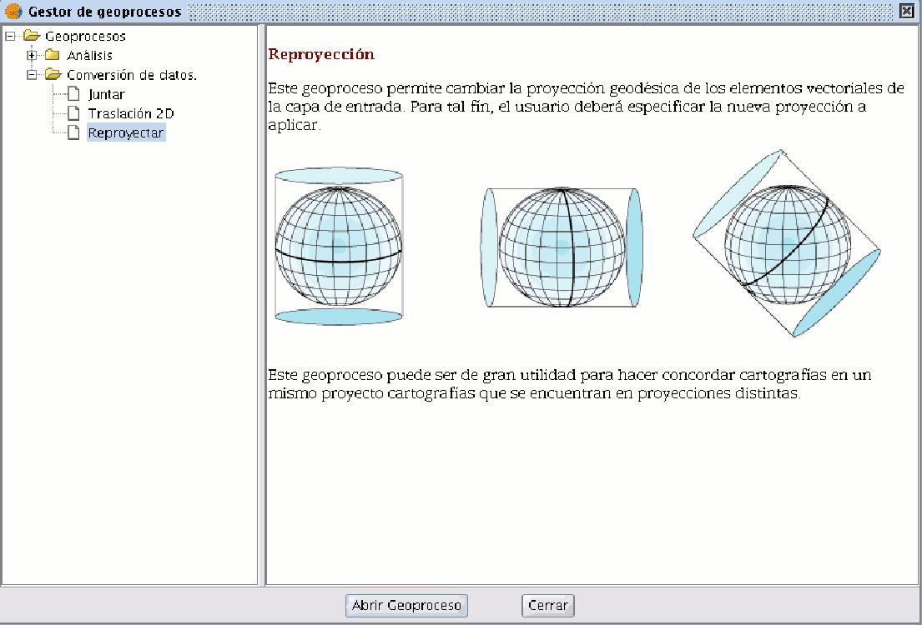

Click on “Open geoprocess”. The wizard will open to guide you through the reprojection process.

In “Input layer”, select the layer you wish to reproject from the layers loaded in the ToC.

To select the new projection for the layer, click on the button next to the destination projection and select the new reference system.
