9 Geoprocesing tools

9.1 Introduction

The gvSIG geoprocessing extension allows you to apply a series of standard processes to the vector information layers loaded in the layer tree in a gvSIG view (ToC), thus creating new vector information layers which will provide new information for the source layers.

The following geoprocesses have been implemented in the first version of the geoprocessing extension:

- Buffer.
- Clip.
- Dissolve (by adjacents and alphanumerical criteria).
- Merge.
- Intersection.
- Join.
- Spatial Join.
- Convex Hull (minimum convex polygon).
- Difference.

The output layer can take one of the output formats supported by gvSIG (it can only be saved in shp format at the moment).

To start the geoprocess wizard, click on the "Geoprocesses" icon in the tool bar
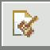

or go to the menu bar and select the “View” option, then “Geoprocess toolbox”.

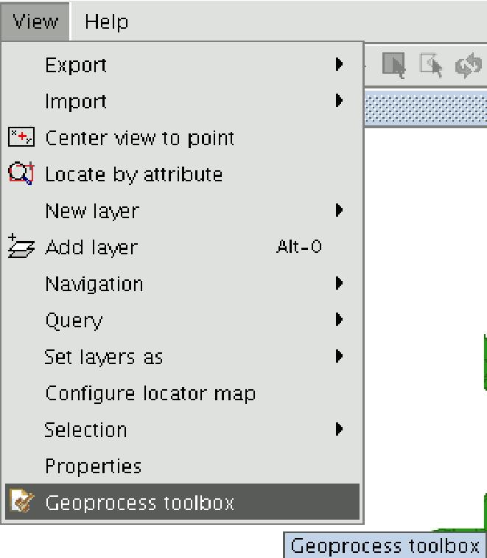

The geoprocess toolbox window will appear.

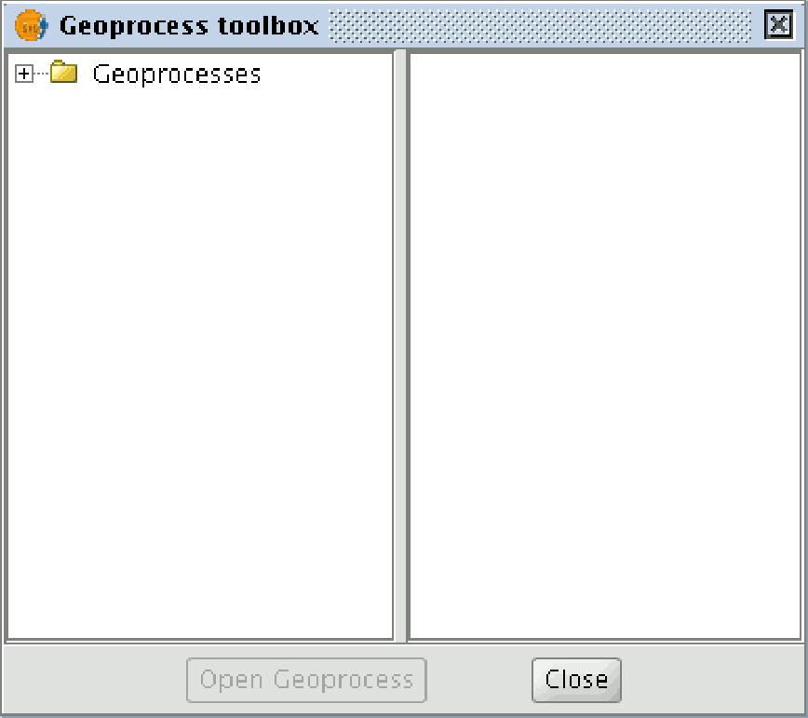

If you click on each of the tree nodes, the different geoprocesses will drop down.

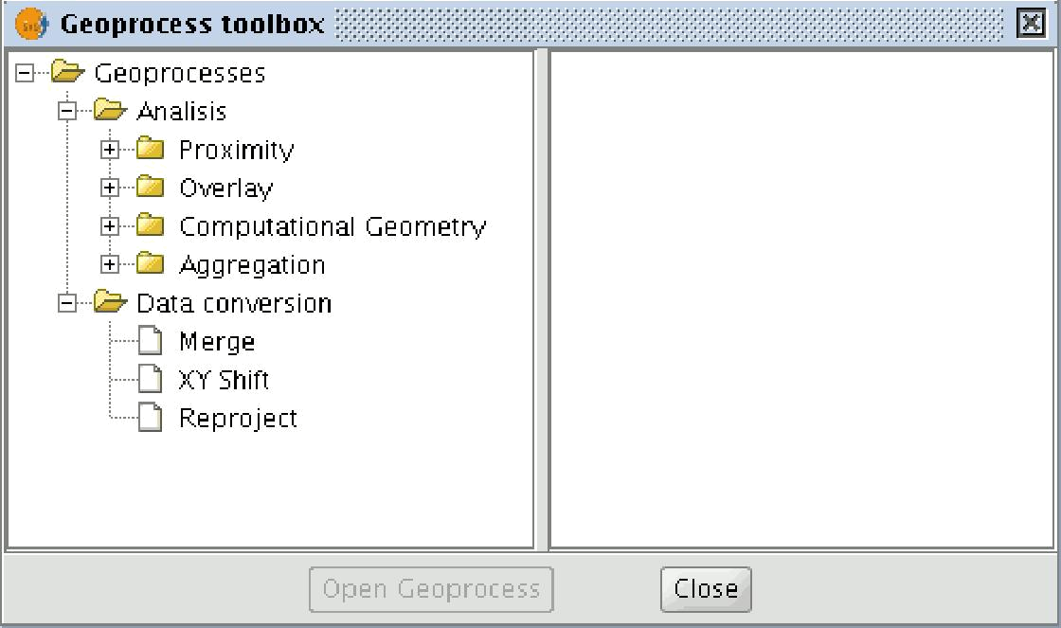

When a geoprocess has been selected, a description of the process will be shown on the right hand side and the "Open Geoprocess" button will be enabled.

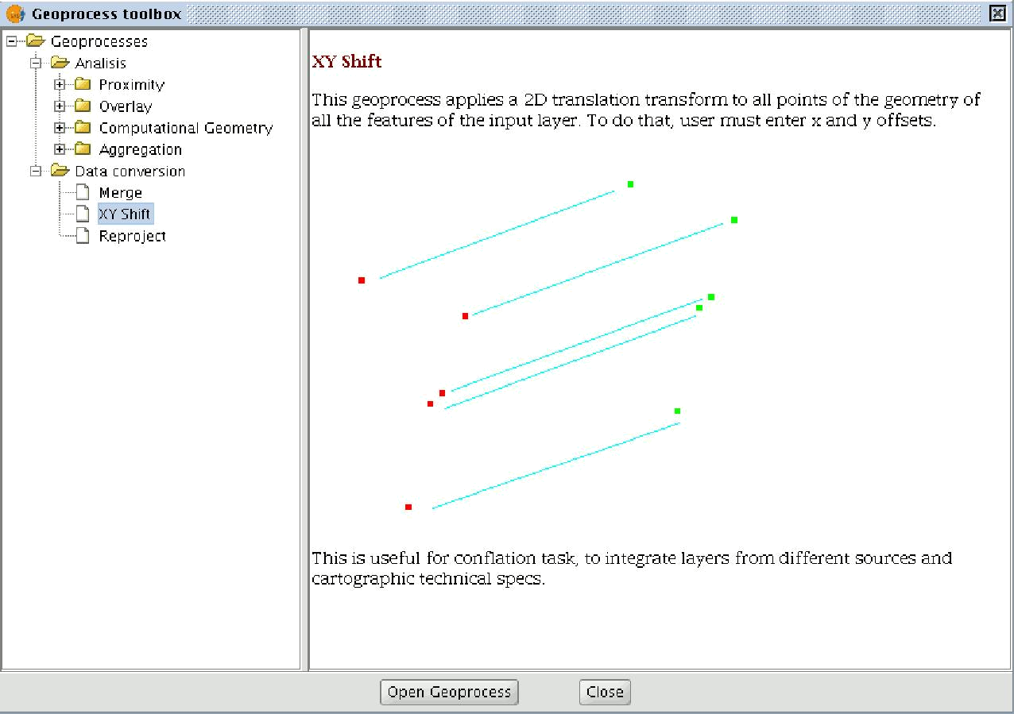

When you find the geoprocess you wish to run, select it in the geoprocess tree and click on the “Open geoprocess” button.
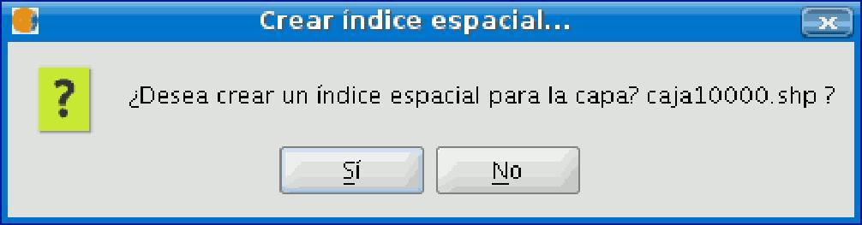
When some geoprocessing tools are applied (for example, Clip) a window appears in which a spatial index can be created for the input layer. This is an internal process which is only carried out once per layer and per new project and speeds up the spatial intersection processes.

To create a spatial index for the input layer which can be used by the geoprocesses, click on “Yes”.

9.2 Accessing the geoprocesses

You can run the geoprocesses available in gvSIG with the geoprocessing wizard by clicking on the following tool bar button:

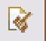

The “Geoprocess toolbox” will appear and you can use it to select the geoprocess you require.

To access the different geoprocesses, pull down the tree in the window shown below (double click with the left button of the mouse on the "Geoprocesses" folder and the rest of the folders will appear).

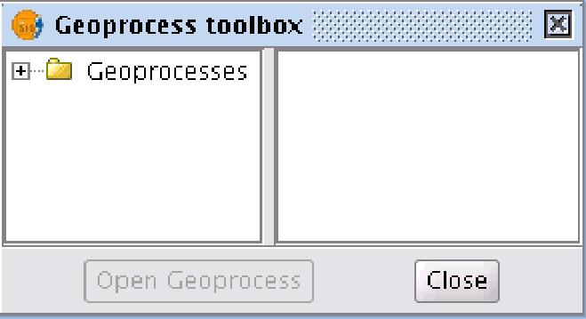

When you have found the geoprocess you wish to use, click on the “Open geoprocess” button.
