5.19 Exporting layers

5.19.1 Introduction

The “Export to...” tool allows you to save the elements selected in a layer in a different format. If no elements have been selected the whole layer will be exported.

At the time of going to press the export formats supported by gvSIG were shape, dxf, and postgis and gml.

5.19.2 Exporting a shape

Select the “Layer” option from the menu bar then go to “Export to…/shp”.

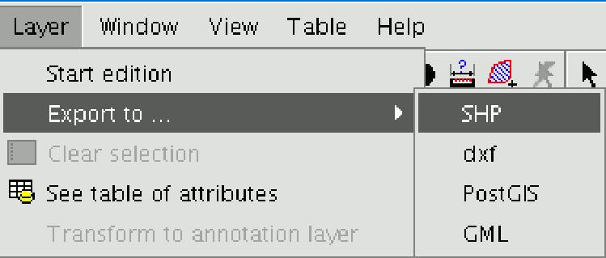

If you have selected elements in the layer to be exported, gvSIG will tell you how many elements are going to be exported and will ask for confirmation before carrying out the operation.

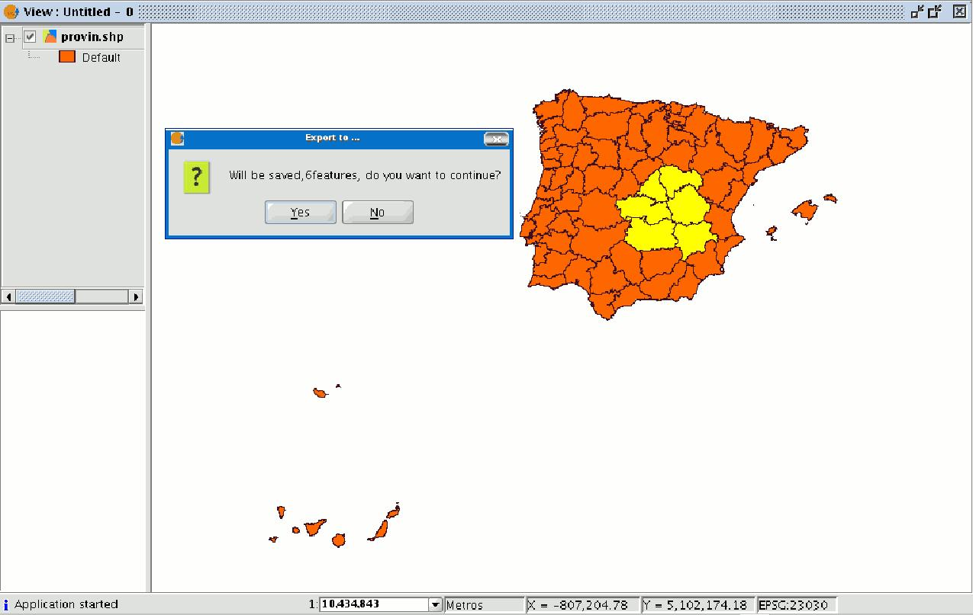

If you continue with the operation, a dialogue box will appear in which you will be asked to select the file the new shape is to be saved in.

When you have accepted, a new message will appear asking whether you wish to insert the new layer into the view.

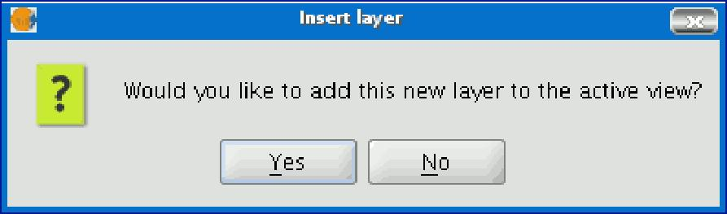

If you click on “Yes”, the layer will be added to the active view.

5.19.3 Exporting to dxf

Select the “Layer” option from the menu bar then go to “Export to…/dxf”.

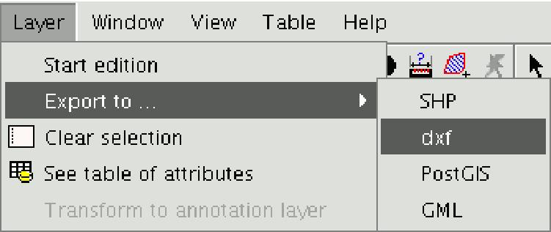

Follow the same process used for exporting to shape.

5.19.4 Exporting to postgis and Oracle Spatial

Select the “Layer” option from the menu bar then go to “Export to…/postgis”.

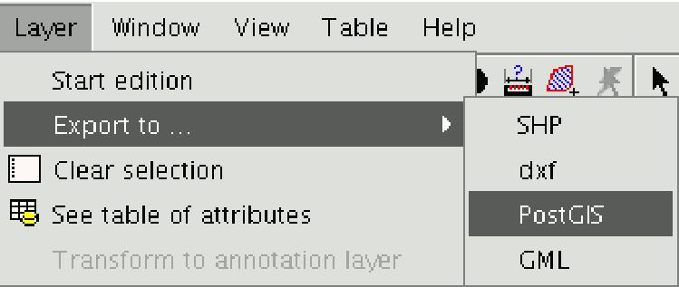

If you have selected any elements, a window will appear telling you how many elements are going to be exported (as in exporting to shp and dxf).

If you click on the “Yes” option to continue the gvSIG exports, gvSIG will ask you to input the name of the table you wish to save the exports in. Remember that if the table already exists in the data base, the information it contains will be deleted.

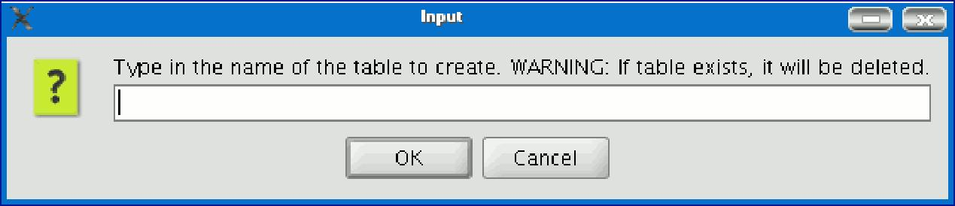

Write the name of the table and click on “Ok”.

A new window appears in which you will have to input the parameters of the data base connection.

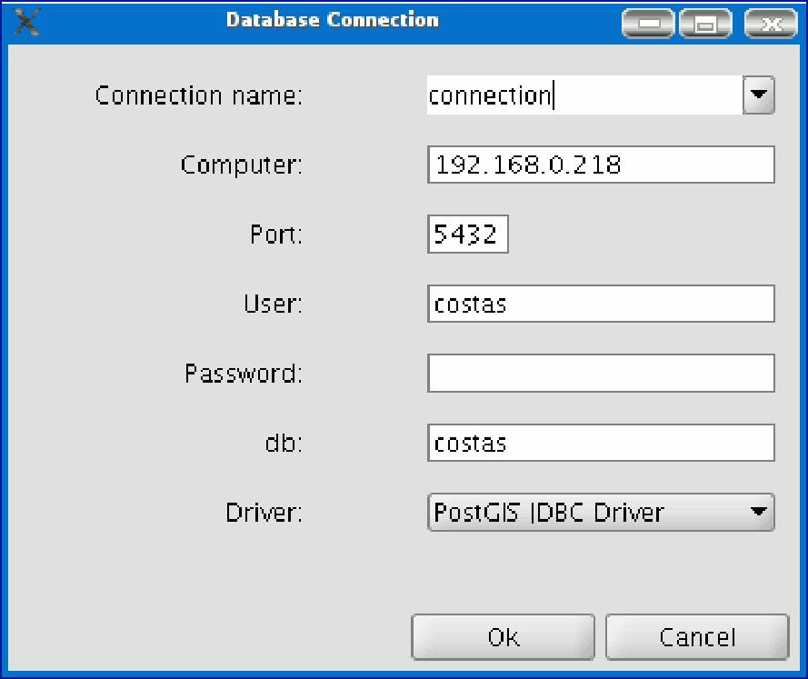

The parameters are:
- Name of the connection.
- Computer: IP address of the computer the data base is hosted in.
- Port: Port on which the computer is listening to the postgreSQL service.
- User: User name recognised by the administrator to make the connection.
- Password: User password required to validate the connection.
- db: The data base the new table is to be created in.
- Driver: Driver required for the data base. (At the time of going to press, drivers for postGIS and mySQL were available).

When you have input the connection parameters, click on “Ok”.

5.19.5 Exporting to gml

Select the “Layer” option from the menu bar then go to “Export to…/gml”.

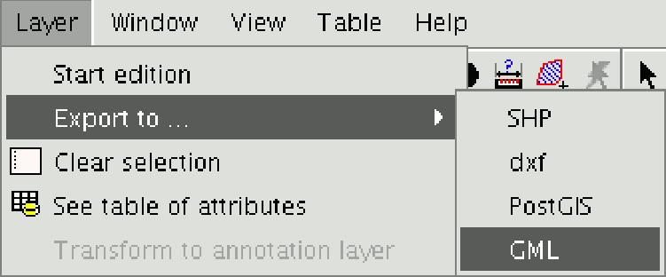

Follow the same process used for exporting to shp or dxf.

5.19.6 Exporting to Oracle Spatial

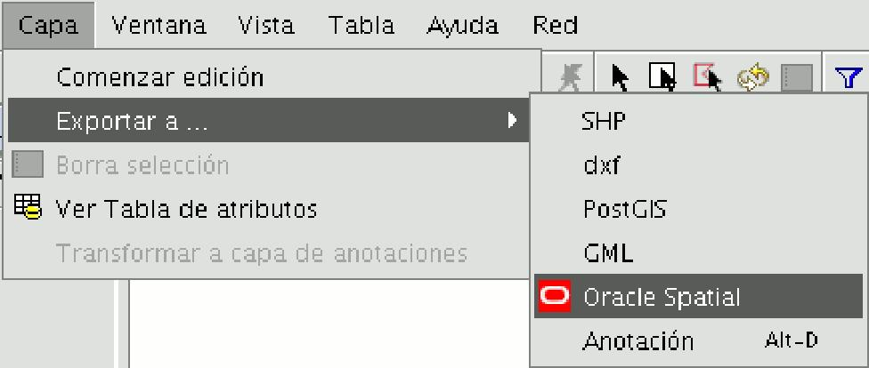

The procedure for exporting to Oracle Spatial is similar to the procedure described above with one difference: for the connection to an Oracle Spatial data base option to be available in the previous connection parameter window, the drivers to enable this process must first be downloaded by following the instructions on the project’s web site. These instructions are summarised below:

The Oracle drivers must be installed to access Oracle Spatial data bases. Follow the steps below:

- Go to Oracle Database 10g Release 2 (10.2.0.3) drivers. (http://www.oracle.com/technology/software/htdocs/distlic.html?url=http://www.oracle.com/technology/software/tech/java/sqlj_jdbc/htdocs/jdbc_10201.html)
- Accept the licence terms.
- Download the file ojdbc14.jar (1,545,954 bytes) classes for use with JDK 1.4 and 1.5 on the following page.
NB. You must register to use the downloaded file
- Move the file to the following folder:
In Windows:
- Move the file to the bin\gvSIG\extensiones\com.iver.cit.gvsig\lib folder. This is in the directory gvSIG is installed in.
In Linux:
- Move the file to the bin/gvSIG/extensiones/com.iver.cit.gvsig/lib folder. This is in the directory gvSIG is installed in.

5.19.7 Exporting to a raster layer

This tool allows you to extract portions of a raster layer using a selection in the view or by inputting the coordinates that define the portion to be extracted. It allows the user to change the spatial resolution of the clipping or of the whole image, choose the bands to be extracted or generate a new raster layer for each of the original bands.

To access this option, go to the ToC and select the raster layer you wish to select a portion of.

Then go to the Layer/Export to menu and select the “Raster” option.

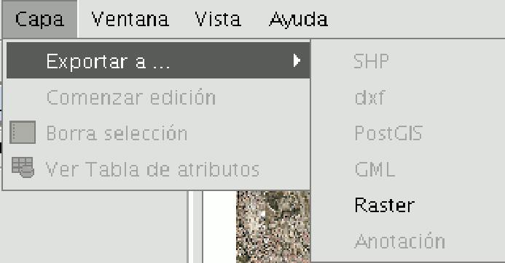

The following window appears:

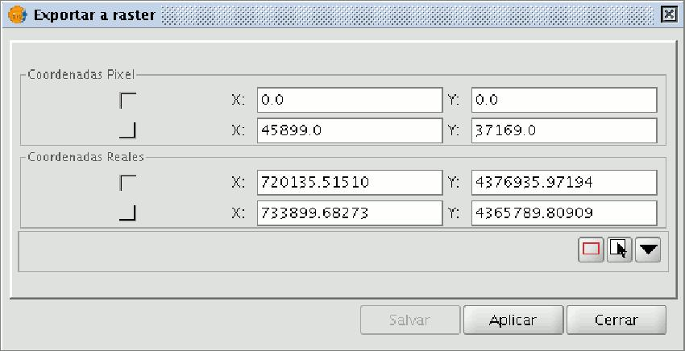

5.19.7.1 Image clipping

There are two ways of selecting an area to be clipped from the original raster layer:
- You can use the text boxes in the window to input the data which correspond to:
- Real coordinates: If the source image is georeferenced.
- Pixel coordinates: If the source image is not georeferenced.

You can also make your selection directly from the view by clipping the whole image or selecting a part of it.
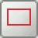
This button allows you to obtain a clipping from the whole image.
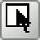
This button allows you to obtain a clipping from a selected area in the view. Place the cursor over the image, then click and drag. Check that the text boxes are automatically completed.

If you wish to save the raster layer clipping you have created, click on “Save” and select the location you wish to save this file in. The image will be saved in TIF format.

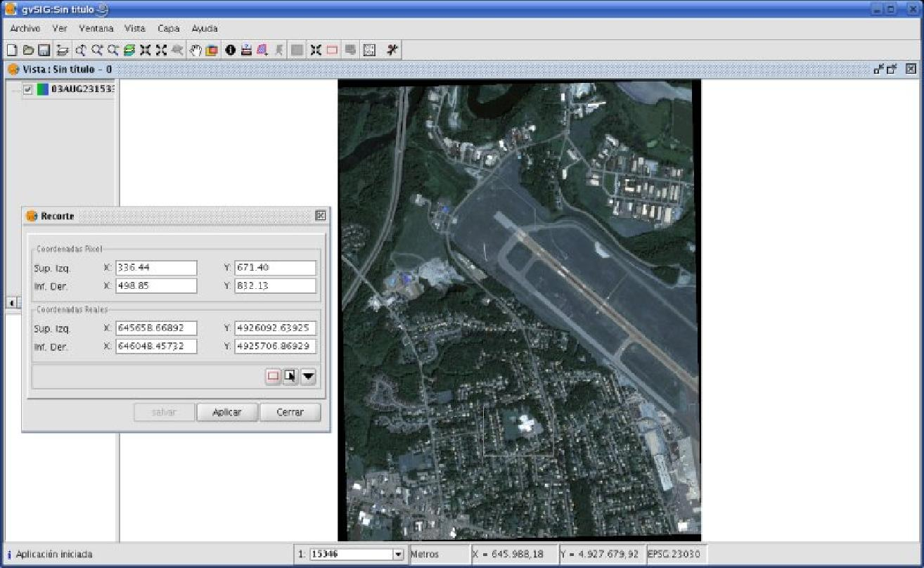

5.19.7.2 Changing spatial resolution


The controls that allow you to specify the clipping’s (or whole image) spatial resolution are located in the Clip table, with the additional options panel pulled down (to pull this panel down click on the button). You can define the resolution by specifying the Cell size or the Width and Height of the raster layer to be generated in pixels as well as choosing the interpolation method using the resolution change. At the moment, only the “Nearest neighbour” option is operational.

