5.16 Catalogue. Searching for geodata

The catalogue service allows you to search for geographic information on the Internet.

gvSIG offers a user-friendly interface which allows you to find geodata and load it in the view, as long as the nature of the data allows this.

5.16.1 Connecting to a server

Before you can carry out a search, you will need to connect to a catalogue server. To access the wizard, you will first need to open a view and then click on the following button:



The first window of the catalogue opens. Input the required parameters to connect to a server. These include:

- The server address.
- The server protocol, which in the case of the catalogue can be:
- Z39.50: General information retrieval protocol.
- SRU/SRW: Variant of Z39.50.
- CSW: Catalogue protocol defined by the OGC in the “Catalogue Interface 2.0” specification.
- Data base name: You only need to indicate the data base you wish to connect to in the case of z39.50. If no value is input you will connect to the default data base.

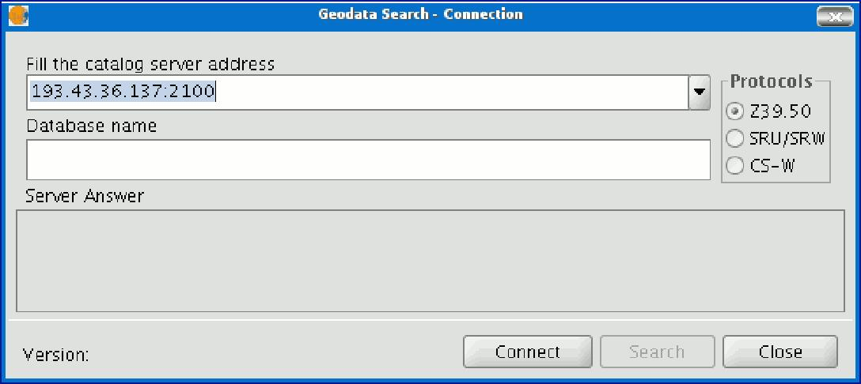

Then click on the “Connect” button. If the connection is made and the server supports the specified protocol, a new window will appear to start the search.

5.16.2 Searching

To carry out a search, you need to fill in the fields that appear in the following form.


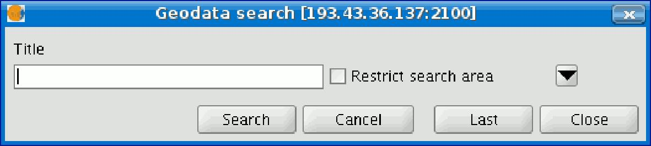


Click on the button and the window will drop down to show more fields which will allow you to carry out an advanced search. The fields you can search in are set by the server. This means that some of the search fields in this form may have no effect in some servers.

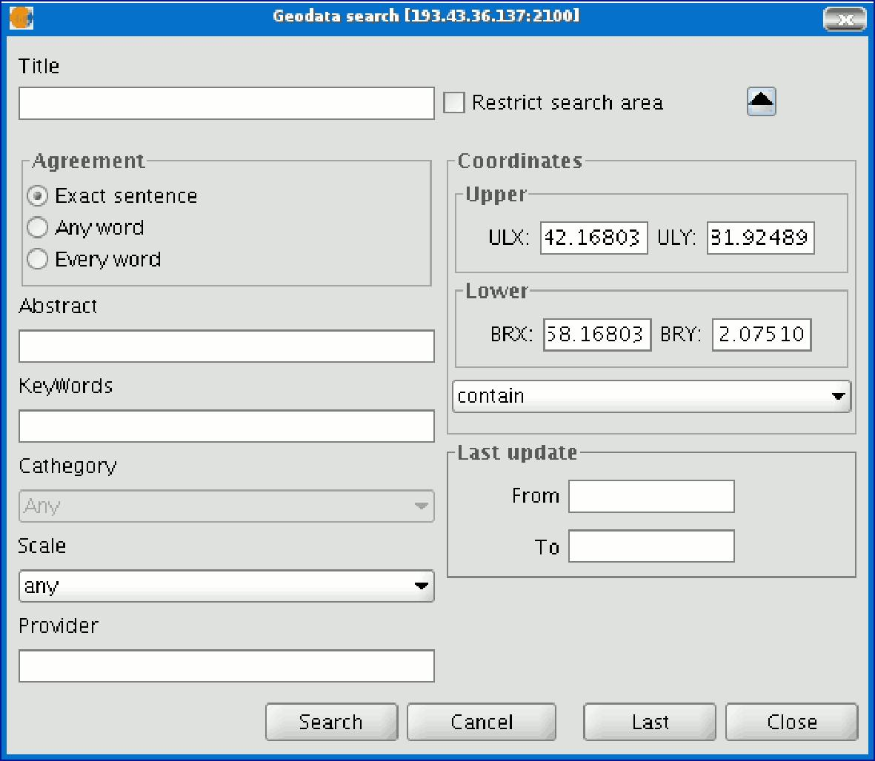

If you change the view zoom, the new coordinates will be reflected in this form. If you wish to restrict the search area enable the corresponding check box.

Then click on “Search” and wait for the search to be carried out.

5.16.3 Viewing the results

If the search has been successful, a new window containing the search results will open. Use the “Previous” and “Next” buttons to see each of the results obtained.

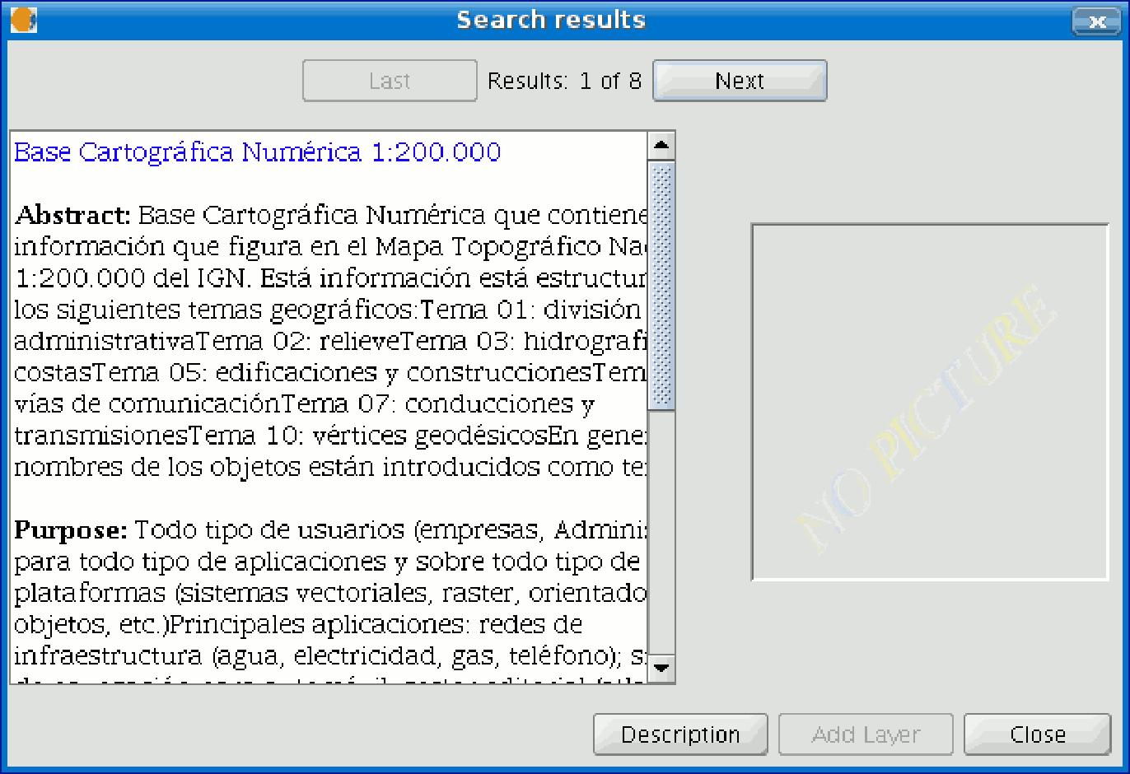

The left-hand side of the window shows information about the metadata obtained. If you wish to see all the information, click on the "Description" button. You will also be able to see a miniature image at all times, metadata permitting.

If the metadata has any geodata associated to it, the “Add layer” button will be enabled. gvSIG can currently recognise different types of associated resources, such as WMS, WCS, Postgis tables and web pages. If you click on this button, a new window will be opened and will show all the resources the application has been able to find.

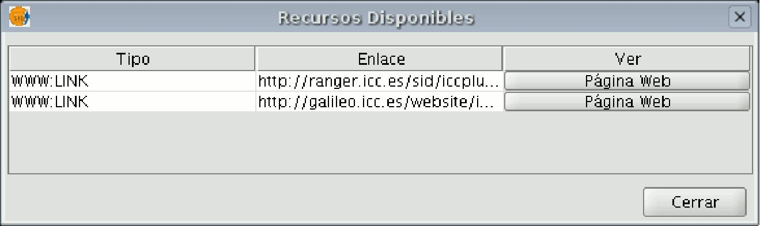

If you click on a WMS, WCS or Postgis type resource, the new layer will automatically be loaded in gvSIG. If the resource is a web page, for example, the operating system’s default browser.

5.17 Gazetteer

A gazetteer is a data set in which a link is established between a toponym and its geographic coordinates.

gvSIG has a catalogue client which allows you to search by toponyms and centre the view on a specific point.

5.17.1 Connecting to a server

Create a view first and open it. The following button will appear automatically in the gvSIG tool bar.

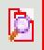

Click on the button. A wizard opens to help you to carry out a search. The parameters to be input are:

- The server address.
- The server protocol, which in the case of the gazetteer can be:
- WFS-G: Toponym search protocol defined by the OGC.
- WFS: Although this protocol was created with a different purpose in mind, it can be used for a toponym search, as long as it has a text attribute in one of the tables. This protocol also allows you to carry out a “Feature” search in any other field, but not necessarily a text attribute.
- ADL: Protocol specified by the Alexandria Digital Library.
- IDEC/SOAP: Protocol that uses the Catalonian Cartographic Institute (ICC) gazetteer web service.

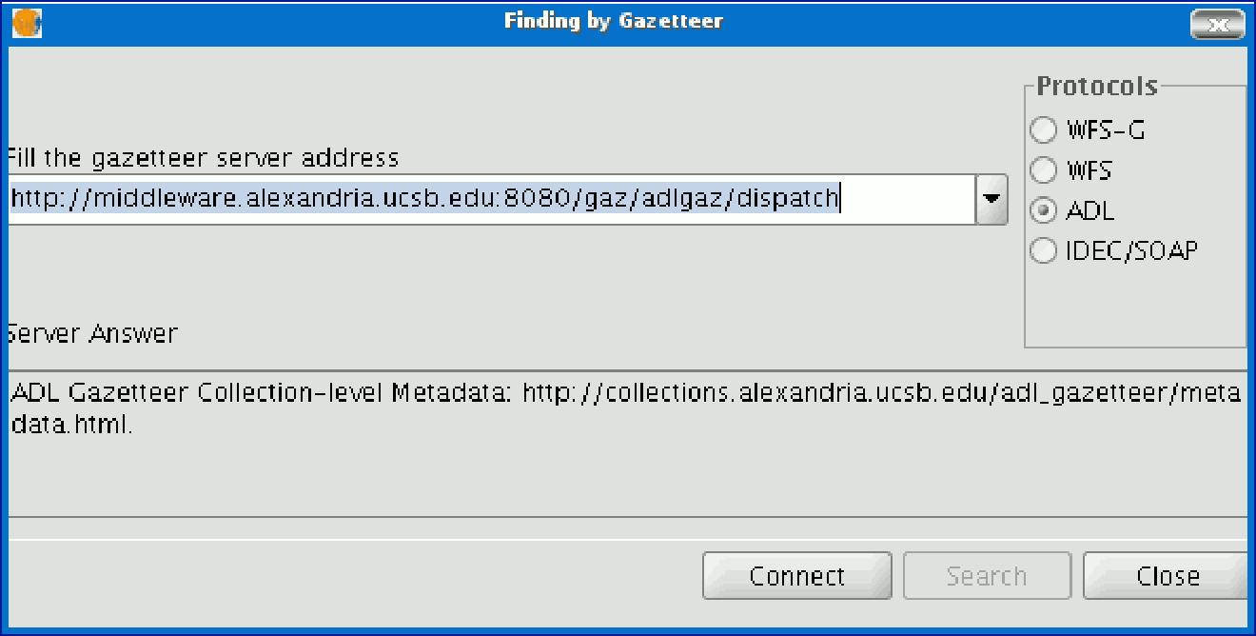

When you have input all the parameters, click on the "Connect" button and wait until the server is found and accepts the specified protocol. If it is accepted, a new window will appear to start the search. If not, an error message will appear.

5.17.2 Searching

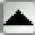
To carry out a search, you will need to fill in the criteria that appear in the following form. You can see the simplified form or carry out an advanced search by clicking on the button in the top right hand corner. This drops down the window.

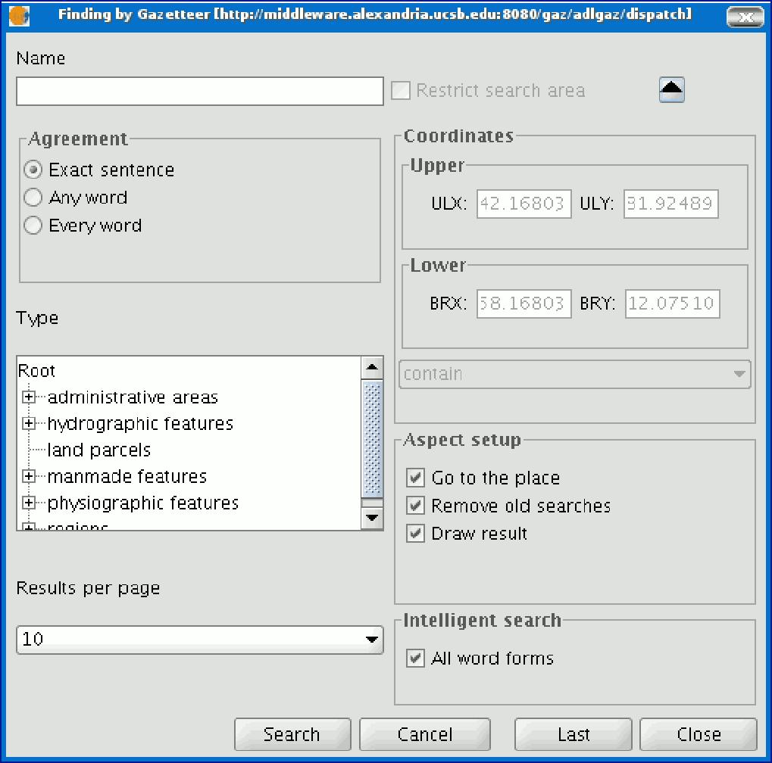

If you change the view zoom, the new coordinates will be reflected in this form. If you wish to restrict the search area activate the corresponding check box.

There are also three options in the “Aspect set up” box which you can use to set up the search view:

- Zoom to search: This puts the toponym found in the centre of the gvSIG view.
- Delete old searches: This deletes all the texts found in the previous searches from the view.
- Draw result: This draws a point and a text label in the place the resulting toponym has been found.

When you have filled in all the fields in the form, click on “Search” and wait for the search to be carried out.

5.17.3 Viewing the results

A new window containing the search results will open. Use the “Previous” and “Next” buttons to move through the different pages of results.

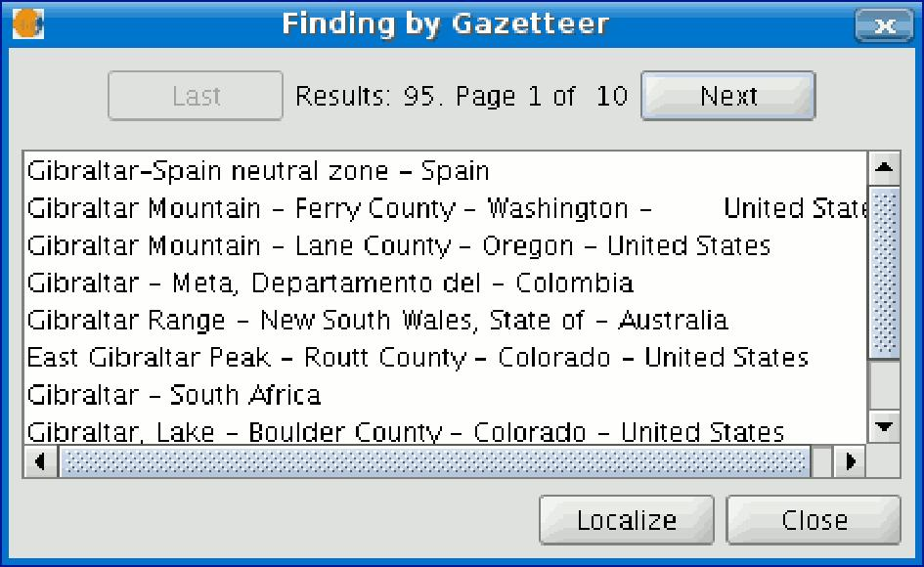

Finally, select the toponym required and click on “Localise”. The gvSIG view will centre on the point the toponym is located in.

5.18 Deleting layers

To permanently remove the active layers from the view, right click on the layer in the ToC and select the “Delete layer” option.
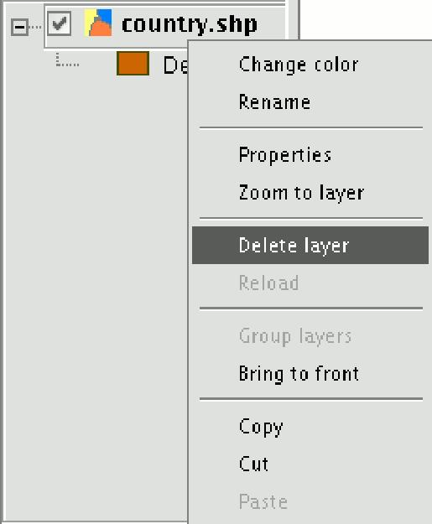

A confirmation dialogue appears.
