5.10 Navigating around / Exploring the view

There are several tools you can use to navigate around the map. These are basically zooms and panning.

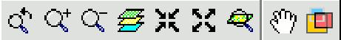

5.10.1 Zooms and panning

You can activate these tools by clicking on the "View” menu and then on “Navigation".


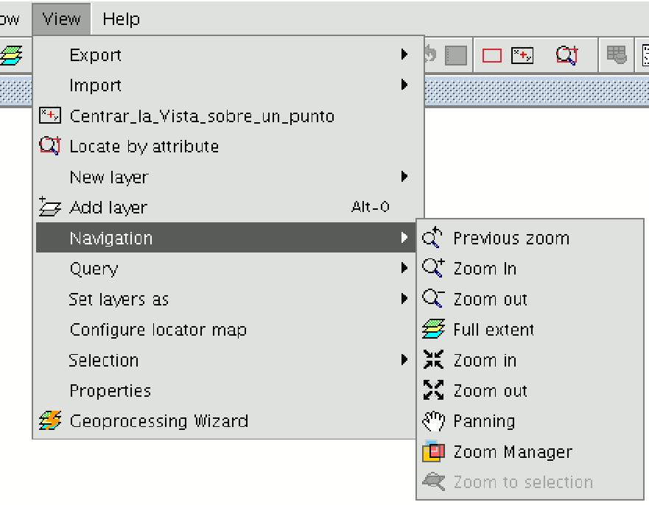

or by using the button bar which is quicker.
Zoom in: Enlarges a particular area of the view.

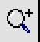

Zoom out: Reduces a particular area of the view.

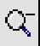

Previous zoom: Goes back to the previous zoom used.



Full extent: Full zoom of the total area included in all the layers of the view.



Panning: This allows you to change the view zoom by dragging the viewing field all over the view with the mouse. Click and hold down the left button of the mouse then move the mouse in the direction you require.



Zoom to selection: Full zoom of the total area of all the selected elements.



Zoom to layer: To zoom to the layer, right click on the selected layer in the ToC, or click on the “Zoom to layer” option in the contextual menu.

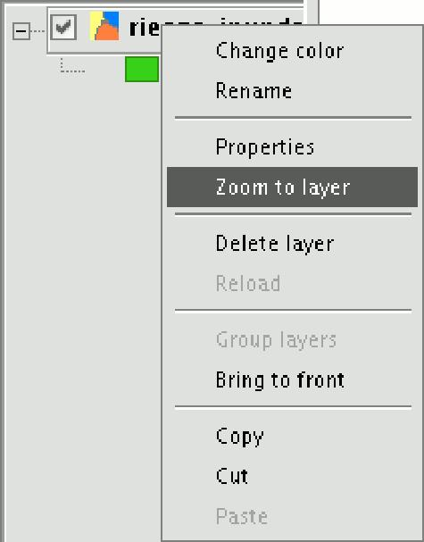

5.10.2 Zoom manager

You can access the “Zoom manager” from the tool bar by clicking on the following button:

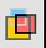

or from the “View” menu, then “Navigation” and “Zoom manager”.

By clicking on the “Zoom manager” you can save a zoom so that you can go back to it at a later stage.

This tool can be used to name the current zoom of the view with the text bar which appears in the window.

Click on “Save” and the zoom currently in the view will automatically be added to the “Zoom manager” text box.

You can create and save as many zooms as you wish. Use the "Select” and “Delete” buttons to manage your working areas.

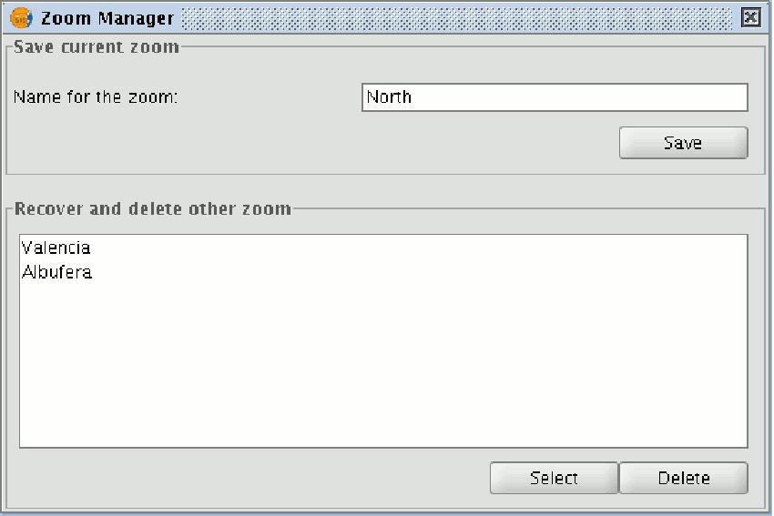

5.11 Configuring the locator map

The locator is a general map which is displayed in the bottom left hand corner of the view's window. It is used to show the working area (main window zoom).

Click on “View” in the menu bar and select “Configure locator map”.

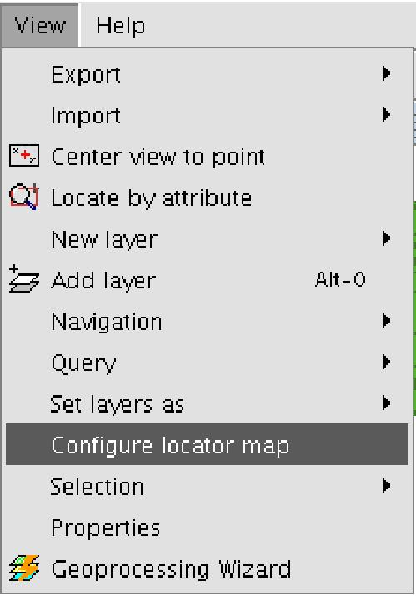

A window appears in which we can add layers (we can add the same types of layers as in the view) which will make up part of the locator map. This window can also be used to remove layers or edit the layers’ legends.

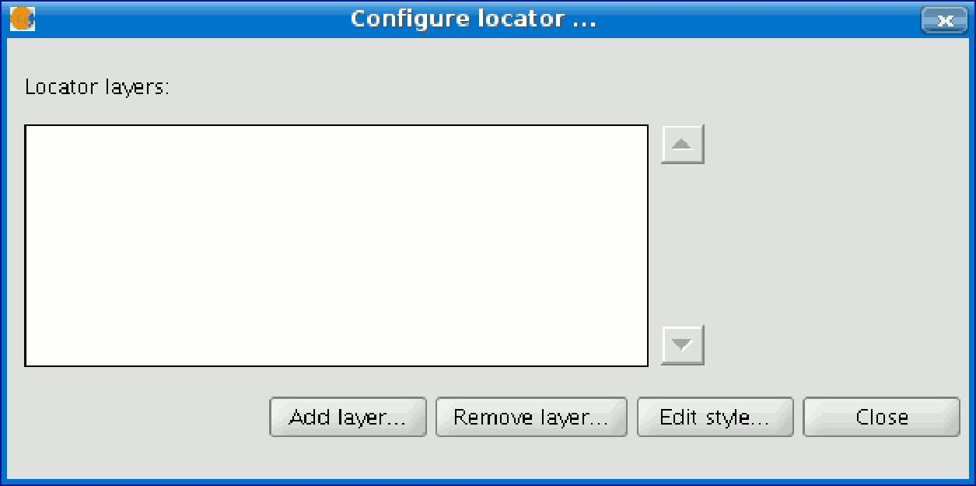

When you click on the “Add layer” button, the following window appears

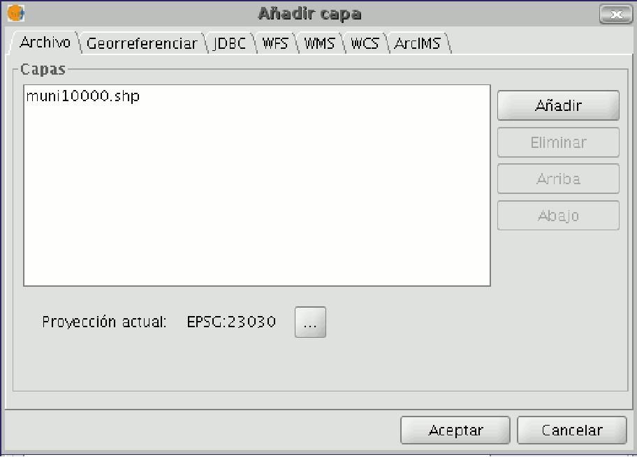

This new function allows the layer loaded in the locator map to be reprojected. To do this, click on the button next to “Current projection when you have selected the layer you wish to load in the locator map.

In the following window, select the reference system you wish the layer to have in the locator map and click on “Finish” for the changes to take effect.

